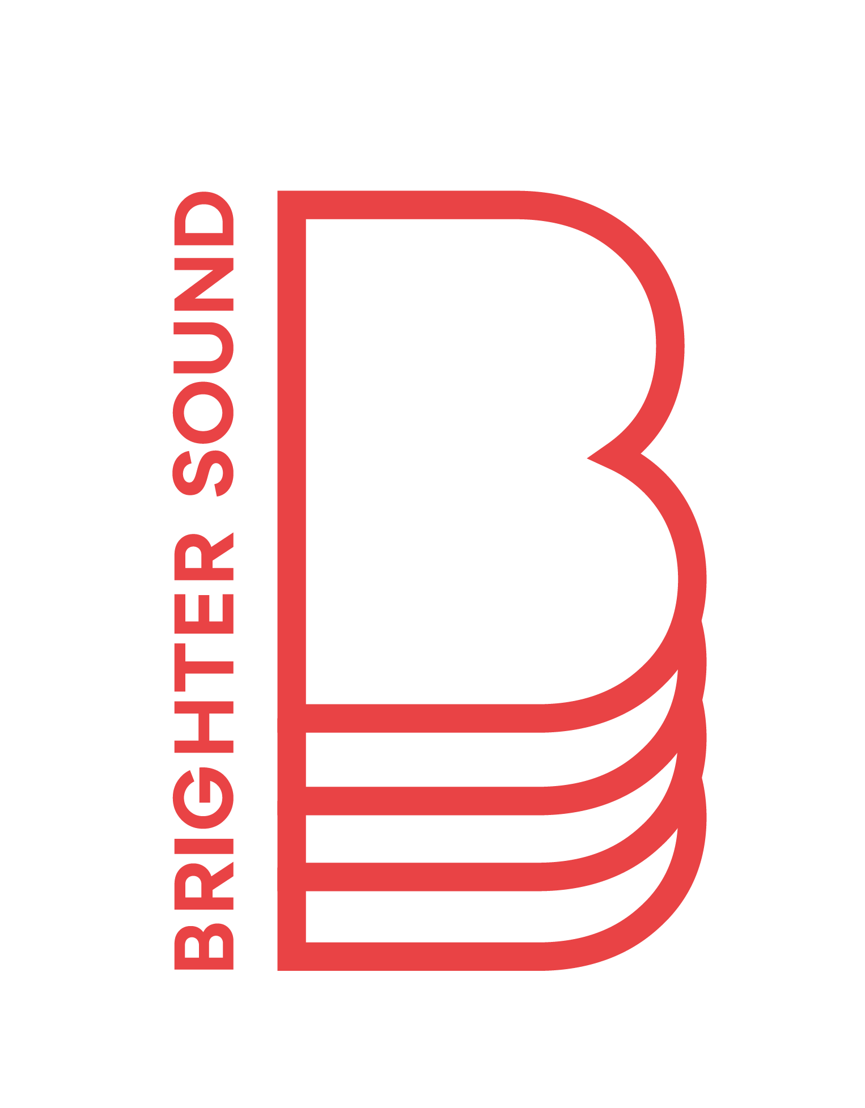

Brighter Sound
Project Coordinator Recruitment Pack
April 2024

Contents

- Welcome
- Who We Are
- What We Do
- Job Description
- Person Specification
- Key Terms & Conditions
- Benefits
- Recruitment Process & Timetable
- How to Apply
- Safeguarding
- Equal Opportunities

Welcome

Hello and thank you for your interest in joining the Brighter Sound team!

This role is an exciting development opportunity for somebody looking to take the next steps in their career in the music or creative industries.

As Project Coordinator you’ll work closely with our Project Managers and Senior Programme Managers to support the successful delivery of a range of exciting and varied music projects. You’ll demonstrate and build experience in a range of areas:

- Arts administration
- Music education
- Outreach projects
- People management
- Live event production
- Creative project management
- Artist development
- Social justice and inclusive practice
- International collaborations
- Marketing and communications

We hope this information pack helps you to understand whether this role is right for you. If you have questions, or would like an informal chat before you apply, please get in touch by emailing Lucy at recruitment@brightersound.com.

Who We Are

“The most significant moment in my career to date. I've made lifelong connections, advanced my skills, gained confidence and acquired memories I'll cherish and draw endless inspiration from” is33n, Artist

Brighter Sound is a pioneering music development organisation, rooted in Manchester and open to the world. We create transformative experiences for young creatives, emerging artists and up-and-coming music professionals. For 24 years we’ve been supporting people to develop creatively, professionally and personally.
Our vision is an accessible, equitable and diverse music landscape; a place where anyone can connect with music to support their life journey.
Our mission is to:

- Support music creators, leaders and professionals at all stages (young, emerging and established) to develop, explore and grow
- Address inequalities and remove barriers to participation so that more people can access creative and professional development opportunities
- Make the North of England a place where musicians and music professionals can thrive and sustain careers

Our values are at the heart of everything we do:

- Champions of the power of creativity
- Grounded in people and place
- Change-makers
- Every voice heard

Central to our approach is the belief that everyone is creative, and that access to music opportunities shouldn’t be limited by who you are or where you live.

Placing equal value on both access and excellence, we recognise that the process is as important as the final product.

What We Do

"Brighter Sound has cultivated a landscape where I can walk in it and claim space."
Clare McNulty, Artist

Working locally, nationally and internationally, we collaborate with a huge network of local and strategic partners across all musical styles and genres, and all areas of the sector - from music education to the music industry.

Our broad programme of activity includes:

- Artistic residencies and commissions
- Community-rooted, co-created workshops
- Mentoring, training and professional development
- Peer-led support networks
- One-off, large-scale, immersive events
- A year-round programme of live performances
- Influential strategy on a local and international level

Over the years we’ve connected our participants to an incredible range of artists and music professionals including Kendrick Lamar, Shiva Feshareki, Anna Meredith, Everything Everything, Loraine James, Snarky Puppy, Wu-Lu and Nubya Garcia.

The breadth and scale of our work has facilitated life-changing engagements with music alongside real social benefits. Each year we work with over 1000 participants, support and employ over 120 independents and deliver more than 170 projects.

In April 2023 we joined Arts Council England’s National Portfolio of Organisations. We’re also the sector lead for Manchester Music City, a partnership of people and organisations working together to support the city’s successful and vibrant music sector and enhance international relationships.
Job Description
We’re looking for a creatively-minded and well organised person to join our team and provide an energetic, thorough and flexible presence across our programme.

Main Areas of Responsibility
- Support the day-to-day delivery of Brighter Sound’s projects, events and initiatives including artistic and logistical design, planning and coordination, project delivery and ongoing monitoring and evaluation
- Be a central point of contact for project participants, practitioners and stakeholders
What will the day-to-day look like?

Based remotely and in our Manchester office, you’ll work within our Programmes Team to support the development, planning and implementation of our projects, events and initiatives. This includes:

Participant Engagement

- Supporting Project Managers to ensure a safe and supportive project environment, applying best practice in relation to safeguarding, risk management and pastoral care
- Building and sustaining relationships with a wide range of project participants - listening to their interests and needs and ensuring they are reflected in the delivery of the programme
- Visiting sessions across the programme, and liaising with partners and delivery teams, to ensure quality assurance in line with Company standards

Relationship Coordination and Communication

- Acting as a central point of contact for project participants, practitioners, partners and volunteers (in agreement with the Project Manager)
- Providing clear lines of communication between all project stakeholders, outlining logistical details and responding to enquiries
- Supporting the development of new and existing relationships with a wide variety of partners

Logistics and Planning

- Supporting the day-to-day delivery of Brighter Sound’s portfolio of work through artistic and logistical planning and coordination, project delivery and ongoing monitoring, evaluation and reporting
- Coordinating equipment, resources, venues and freelance personnel such as facilitators, guest artists, videographers and photographers across projects
- Data monitoring and inputting to support consistent and accurate information across all company activities

Person Specification

What are we looking for?

Essential

- At least two years experience working within arts or creative administration, or an ability to demonstrate transferable skills in this area
- An understanding of, and commitment to, diversity and inclusion
- An understanding of safeguarding of children and vulnerable adults
- A team worker with a can-do attitude and the confidence and initiative to work alone
- Strong administrative and organisational skills, with excellent attention-to-detail
- The ability to plan and prioritise workload
- Confidence in written and verbal communication
- An interest in supporting children and young people to access high-quality music opportunities
- A passion for live music, events and creative music projects
- An interest in supporting equitable change in the music industry
- The ability to work flexibly including out-of-hours and weekends
- An eagerness to learn and a commitment to your own professional development

Desirable

- Professional experience within the music industry or music education sector
- Experience of working with children and young people and implementing safeguarding measures
- Experience of managing budgets
- An understanding of the local music scenes
- Working knowledge of music equipment and technology

Key Terms and Conditions

Salary | £24,000 (pro-rata)
Responsible to | Senior Programme Manager (Line Management)  Project Managers (Task Management)
Responsible for | Freelance Facilitators and Artists
Working with | Programmes Team, Marketing and Communications Team, Operations and Finance Team, Freelance Workforce, Professional Artists, Project Participants, Manchester Music City Board and Network, and a wide range of external partners.
Type of Contract | Fixed-term, 12 months  Subject to a two-month probationary period
Hours of Work | Part-time, 4 days per week (28 hours)  0.8 Full-Time Equivalent (FTE)  As part of the role, some evening and weekend work will be required.
Location | Manchester, with some home-working.  We’re operating a hybrid way of working and support our staff to make use of remote working options when combined with regular office days.  As part of the role, some travel around the UK may be required.

Benefits of working at Brighter Sound

- A passionate and supportive team
- Central Manchester location
- A mixture of office and home-working
- 25 days annual leave per year (pro-rata) plus bank holidays. In addition, Brighter Sound is closed between Christmas and New Year. You don’t need to use any of your annual leave entitlement to cover this period
- Pension scheme - contribution of 5% of eligible salary

Health and wellbeing support via our Employee Assistance programme

Recruitment Process & Timeline

Deadline for applications | Sunday 28th April, 11pm
Shortlisting completed and candidates notified | Wednesday 1st May
Interviews | Tuesday 7th May

Once shortlisting is complete, we’ll let every applicant know whether they have been successful in making it through to the next stage.

Interviews will be held in central Manchester. If you’re invited to an interview, we’ll cover the cost of travel expenses.

We’re keen for the successful candidate to start as soon as possible, though we will of course work around any existing notice periods.

How to Apply

To apply please send us:
- A current CV
- A cover letter telling us why you’re interested in the role, and how you think you’d be a good fit (you can do this in writing or by sending us a video or audio file) Please make sure you refer to the key responsibilities and person specification when writing your cover letter
- A completed Equal Opportunities form

Please email your application to recruitment@brightersound.com by Sunday 28th April, 11pm.

If you’re writing a cover letter, please keep it to no more than two sides of A4. If you’d rather record, please keep it to no longer than five minutes.

If you have any questions or if there are any adjustments that would support you in your application or the interview process, please let us know. For example, if you need this information in a different format.

Safeguarding

The safety and wellbeing of our beneficiaries is of utmost importance. Safeguarding is therefore a major consideration during recruitment, and we take a robust approach when recruiting employees or volunteers.

Successful candidates will undergo a DBS (Disclosure and Barring Service) Check, an appropriate level of Safeguarding Training and will need to provide references which both help to confirm their ability to work with us and support an assessment of their suitability for the role and its safeguarding responsibilities.

Please read our Safeguarding Policy for more information.

Equal Opportunities

Brighter Sound is committed to building a diverse workforce and welcomes applications from candidates of all backgrounds. We encourage you to apply no matter your age, caring responsibilities, disability, gender, gender identity, marriage and civil partnership, pregnancy and maternity, race, religion or belief and sexual orientation.

We’re particularly committed to supporting applications from people with backgrounds or social groups that are currently underrepresented in the creative industries including D/deaf, Disabled and/or neurodivergent people, and people from the Global Majority*.
Brighter Sound is proud to be a Real Living Wage employer. We are committed to accessibility and compliant with the Equality Act 2010. As a Disability Confident employer we guarantee an interview to anyone with a disability whose application meets the minimum criteria for the post. By ‘minimum criteria’ we mean that applicants must provide evidence in their application that demonstrates how they meet the requirements set out in the person specification. To be considered under the Guaranteed Interview Scheme, applicants will need to declare that they have a disability.
*Global Majority is a collective term that refers to people who are Black, Asian, Brown, dual-heritage, indigenous to the global south, and or have been racialised as ‘ethnic minorities’. Globally, these groups currently represent approximately 80% of the world’s population. (Source: Rosemary Campbell-Stephens MBE, Leeds Beckett University)

Want to find out more?
Hear from our community and watch our brand film.

Thank you to our supporters:
Arts Council England, Youth Music, Manchester City Council, GMCA, The Granada Foundation, PRS Foundation as a Talent Development Partner (supported by PPL).

