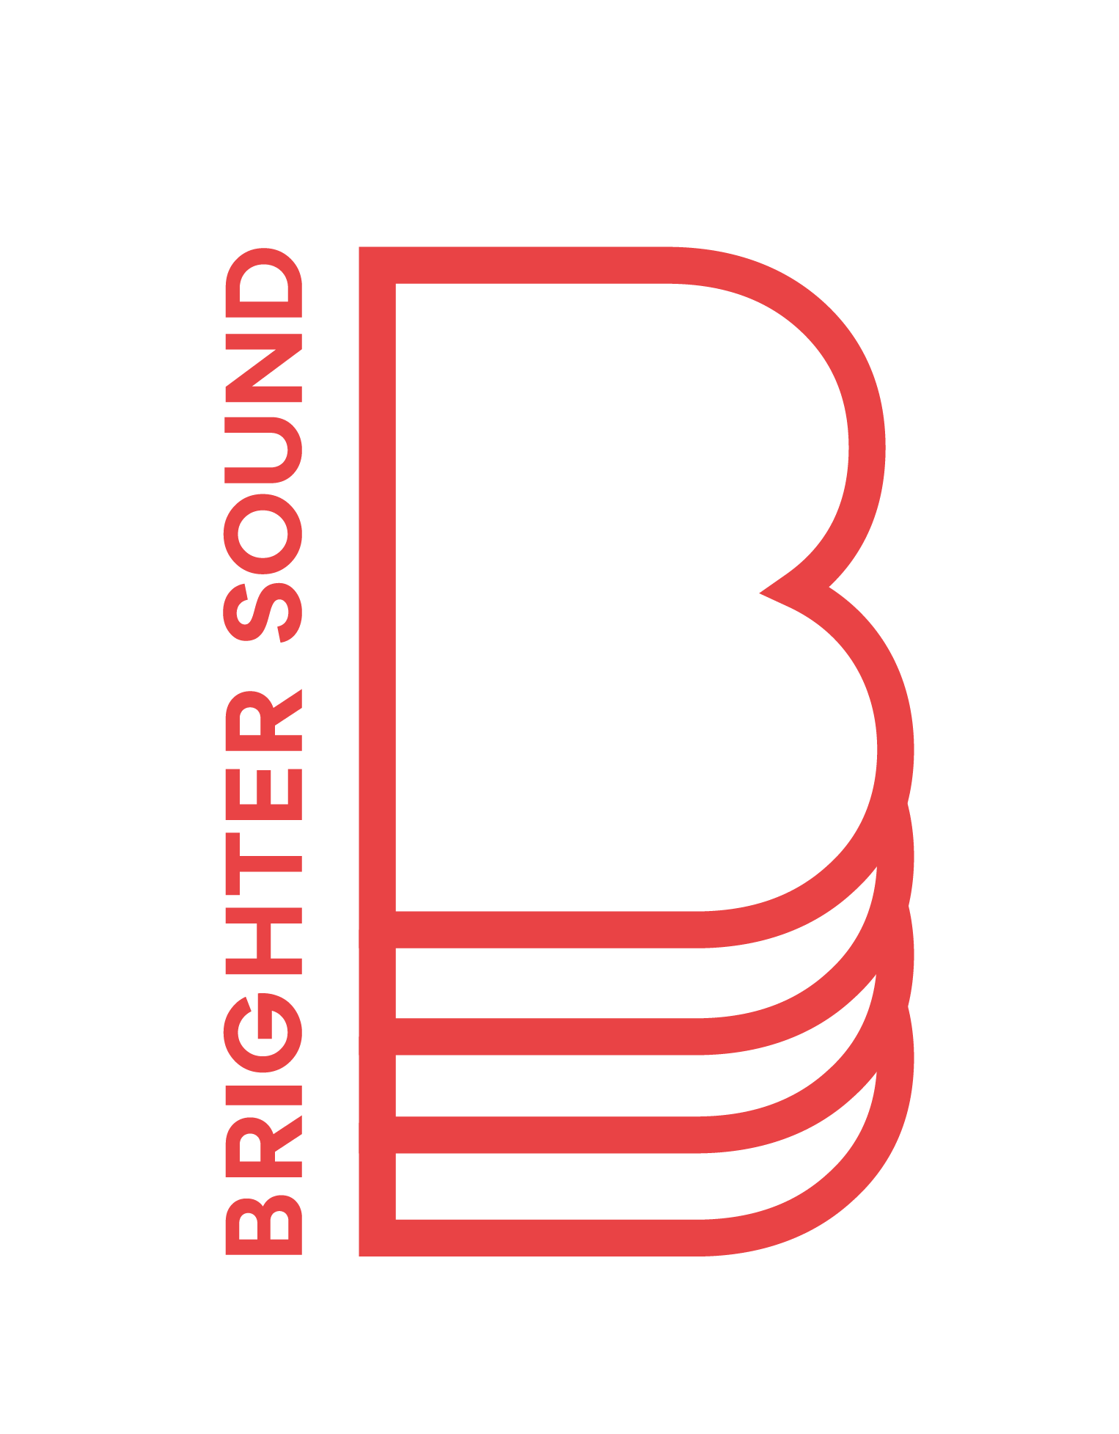

**Brighter Sound  
Freelance Support Music Facilitators**

**Recruitment Pack**

**Contents**

Job Overview 1

Job Description 2

Person Specification 3

When and Where 4

Recruitment Process 5

How to Apply 6

Safeguarding 6

Equal Opportunities 7

About Brighter Sound 8

## **Job Overview**

| **Role titles** | Freelance Support Music Facilitators |
| --- | --- |
| **Fee per role** | £1870 inclusive of 12 half day delivery sessions, planning, 1 half day evaluation and 1 day training.  Additional £200 to attend 4 supervision sessions.  Travel expenses available outside of the Rochdale borough. |
| **Working with** | Brighter Sound Project Management Team, Brighter Sound Project Coordinator, Lead Music Facilitator, Youth Workers. |
| **Type of Contract** | Fixed-term, freelance  **There are two separate projects. You can apply for either or both.** |
| **Locations and Hours of Work** | 12 sessions per project, plus additional supervision support, across March-July 2025 in the Rochdale/Middleton areas.  There will also be one mandatory training day on Wednesday 19 March. |
| **Deadline** | Friday 21 February 2025, 11pm |

## **Job Description**

Brighter Sound is running two 12-week engagement projects in the Rochdale borough for young people aged 11-18 who are facing significant challenges in their lives.

We’re offering two roles to support 12 creative music-making sessions responding to participants' interests and needs, utilising non-formal, youth-led, co-created trauma-informed approaches.

You will ensure a safe and supportive project environment, applying best practice in relation to safeguarding, risk management and pastoral care.

Both roles include mandatory training in safeguarding and trauma informed practices and group supervision sessions; a confidential space for reflection, support and learning with a mental health practitioner.

We’re looking for collaborative, flexible and empathic Freelance Music Facilitators to work alongside a Lead Music Facilitator to:

* Support improvement in the lives of young people aged 11-18 facing significant challenges, nurturing personal and social growth through music-making
* Be creatively ambitious, sharing different ways of making music with young people and encouraging their musical interests - whether that be to simply have a go, or try out new equipment or styles
* Inspire young people to grow resilience, increase confidence and become more aspirational
* Foster curiosity and interest in further creative activities with the potential to inspire young people to consider pursuing a creative career
* Support the development of young people’s personal and social skills through music to enable them to pursue future pathways within education or employment

## **Person Specification**

**Essential**

* Experience and an understanding of working with children and young people and implementing safeguarding measures, including relevant qualifications
* Experience of facilitation with groups of young people in collaborative creative music-making activities
* A passion for supporting children and young people to access high quality music opportunities
* Skills in some or all of the following:
  + Vocal work
  + Songwriting
  + Instrumentation
  + Electronic music production
* Punctuality and initiative in setting the session space
* An understanding of and commitment to diversity, inclusion, and the differing needs of young people when working in complex settings
* An up-to-date DBS check, or be willing to take one

**Desirable**

* Knowledge and/or experience of trauma Informed and co-creation practices and theories
* Based in or near to the Rochdale borough

## **When and Where**

**Rochdale Youth Service**

Sessions on the following Mondays will take place in Middleton between 12.30-3.30pm:

31 March

7, 14, 28 April

5, 12, 19 May

2, 9, 16 June

There will also be two holiday sessions taking place between 1-3.30pm on Monday 14 April (Middleton) and Thursday 17 April (Heywood).

**Rochdale Connections Trust**

Sessions on the following Wednesdays will take place in Rochdale town centre between 3-6pm:

April 2, 9, 16, 23, 30

May 7, 14, 21, 28

June 4, 11, 18

All times are inclusive of setting up, delivery and debriefing.

## **Recruitment Process**

| **Deadline** | **Friday 21 February 2025, 11pm**  We encourage you to submit your application before the deadline but if you need a bit more time please let us know by Wednesday 19 February. |
| --- | --- |
| **Shortlisting completed and candidates notified** | Friday 28 February |
| **Interviews** | Monday 3 March |

Once shortlisting is complete, we’ll let every applicant know whether they have been successful in making it through to the next stage.

Interviews will be held at the Brighter Sound offices in central Manchester (Green Fish Resource Centre, 46-50 Oldham Street, Manchester, M4 1LE).

If you’re invited to an interview, we’ll cover the cost of travel expenses.

We’re keen for the successful candidate to start as soon as possible, though we will of course work around any existing notice periods.

## **How to Apply**

Please complete [an online application](https://docs.google.com/forms/d/e/1FAIpQLScQQ0-0iH6UFB8bSvXbFD-jBWXl-nA8eG42HEdBa2YLLqdHzg/viewform?usp=header) by Friday 21 February 2025, 11pm.

If you have any questions or if there are any adjustments that would support you in your application or the interview process, please let us know. For example, if you need this information in a different format.

You can get in touch by emailing Tim Chatterton at [recruitment@brightersound.com](mailto:recruitment@brightersound.com) or calling 0161 546 5334.

## **Safeguarding**

The safety and wellbeing of our beneficiaries is of utmost importance. Safeguarding is therefore a major consideration during recruitment, and we take a robust approach when recruiting employees or volunteers.

Successful candidates will be asked to complete a self disclosure form, undergo a DBS (Disclosure and Barring Service) Check, an appropriate level of Safeguarding Training and will need to provide references which both help to confirm their ability to work with us and support an assessment of their suitability for the role and its safeguarding responsibilities.

Please read our [Safeguarding Policy](https://www.brightersound.com/legals/safeguarding-policy/) for more information.

## **Equal Opportunities**

Brighter Sound is committed to building a diverse workforce and welcomes applications from candidates of all backgrounds. We encourage you to apply no matter your age, caring responsibilities, disability, gender, gender identity, marriage and civil partnership, pregnancy and maternity, race, religion or belief and sexual orientation.

We’re particularly committed to supporting applications from people with backgrounds or social groups that are currently underrepresented in the creative industries including D/deaf, Disabled and/or neurodivergent people, and people from the Global Majority*.

Brighter Sound is proud to be a Real Living Wage employer. We are committed to accessibility and compliant with the Equality Act 2010. As a Disability Confident employer we guarantee an interview to anyone with a disability whose application meets the minimum criteria for the post. By ‘minimum criteria’ we mean that applicants must provide evidence in their application that demonstrates how they meet the requirements set out in the person specification. To be considered under the Guaranteed Interview Scheme, applicants will need to declare that they have a disability.

*Global Majority is a collective term that refers to people who are Black, Asian, Brown, dual-heritage, indigenous to the global south, and or have been racialised as ‘ethnic minorities’. Globally, these groups currently represent approximately 80% of the world’s population. (Source: Rosemary Campbell-Stephens MBE, Leeds Beckett University)

## **About Brighter Sound**

[We're Brighter Sound](https://www.youtube.com/watch?v=si5pWbnIMfI)

*“The most significant moment in my career to date. I've made lifelong connections, advanced my skills, gained confidence and acquired memories I'll cherish and draw endless inspiration from”* is33n, Artist

[Brighter Sound](https://www.brightersound.com/) is a pioneering music development organisation, rooted in Manchester and open to the world. We create transformative experiences for young creatives, emerging artists and up-and-coming music professionals. For 24 years we’ve been supporting people to develop creatively, professionally and personally.

Working locally, nationally and internationally, we collaborate with a huge network of local and strategic partners across all musical styles and genres, and all areas of the sector - from music education to the music industry.

Our broad programme of activity includes:

* Artistic residencies and commissions
* Community-rooted, co-created workshops
* Mentoring, training and professional development
* Peer-led support networks
* One-off, large-scale, immersive events
* A year-round programme of live performances
* Influential strategy on a local and international level